SIMcheck是Micron Oxford小组（Department of Biochemistry, University of Oxford）基于Java开发的ImageJ插件包，目的是评估结构光照明显微镜数据质量和可靠性。

为了学习SIMcheck的使用，本文从以下几个方面进行详细的阐述。

1.安装

### 2. Raw Data Checks（原始数据检查）

#### Channel Intensity Profile (CIP)



Supplementary Figure S3 | Generation of Channel Intensity Profiles (CIP). (a) Raw data image stack of a HeLa cell immunostained for microtubules (detected with Alexa Fluor 488 conjugated secondary antibodies) acquired on an OMX V2 instrument (Supplementary Data 2a). From a central z-section (Z56), the image for phase step 1 (P1) of angle 1 (A1) is shown. (b) Orthogonal view of raw data stack with acquisition angles A1 - A3 and z-slices shown with the first slice (Z1) at the top, and the last slice (Z145) at the bottom for each angle (only P1 shown). Scale bar: 5 μm. (c) SIMcheck output with the relative mean intensity of each frame plotted on the y-axis, and the order of the slices, separated by angle, on the x-axis. Five phase steps (P1-5) are acquired per z-slice and angle, resulting in 145 x 5 = 725 images per angle in the dataset. The employed OMX V2 system uses a mechanical phase grating for the pattern generation and acquires image stacks for different rotation angles sequentially. Accordingly, 荧光强度衰减——光漂白fluorescence intensity decreases through the zstack and with each consecutive angle due to photobleaching. Below is the corresponding SIMcheck log output, providing the total intensity variation (TIV) within a window of 9 central z-sections contributing to reconstruct one super-resolution z-section (marked light grey). In addition statistics on the average decay rate per angle(due to photobleaching), maximum intensity difference between angles(due to miscalibration）and relative intensity fluctuations (due to illumination flicker)are provided to diagnose selective contributions to the TIV. (d) Table comparing the acquisition order and raw data format of the three commercially available SIM platforms. GE’s OMX platform comes with either a rotary diffraction grating (V2/V3) where angle rotation is the last step, or a rapid angle-switching device (V3/V4 Blaze), which has a different acquisition order. It should be noted that acquisition on these instruments may be switched by the user between “all channel then Z” or “all Z then channel”. While the raw data format varies between manufacturers, SIMcheck is written to accommodate by default the GE data format, and therefore datasets from other manufacturers need to be converted either from the main dialog or separately with the Format Conversion tool prior to analysis with any of the standalone checks and utilities.

#### Raw Fourier Projection (FPJ)



Supplementary Figure S4 | Generation of raw data Fourier Projection (FPJ). (a) Raw data from a field of green 110 nm diameter fluorescent beads (FluoSphere 505/515, Life Technologies), demonstrating how each illumination angle is considered as a separate z stack for the construction of the Raw Fourier Projection (FPJ) check直径110nm的绿色荧光微球。。。在图像堆某一层，利用不同照明条纹角度重建合成的傅立叶投影. Data acquired on a GE OMX V3 Blaze instrument (Supplementary Data 3a). Scale bar: 5 μm. (b, c)Illustration of intermediate processing steps to generate the final FPJ output. (b) A 2D fast Fourier transform (FFT) is applied to generate a 32-bit amplitude2 Fourier power spectrum that is logarithmically scaled to enhance detection of high frequencies. 采用对数坐标增强高频的检测Middle panel shows a diagrammatic representation of the window function that is multiplied to each raw data image before applying the FFT. 窗函数This removes “edge artifacts” that otherwise appear as stripes along the axes of the Fourier spectrum of unprocessed data (bottom left, arrowheads).边界效应引起的条纹状的伪影 (c) An intermediate FFT stack is assembled (Stack FFT utility) and a maximum intensity projection generated over all three angles combined. For the final output the central region is masked before rescaling to enhance the contrast of the relevant higher frequency range.频谱中心掩膜处理以增强高频的范围The processing steps enable at a glance to assess the presence and quality of first (inner) and less intense second order (outer) spots, corresponding to first and second order stripes in the structured illumination pattern.评估一阶和二阶点是否存在及其质量

This check requires that the sample fills a significant proportion of the volume and that the signal-to-noise is adequate, in order to see second order spots.

* This check requires that the sample fills a significant proportion of the volume and that the signal-to-noise is adequate, in order to see second order spots. Sparsely fluorescent samples, such as isolated point-like objects would not show prominent spots even though the data quality may be sufficient. 稀疏的荧光样品以及低信噪比不可用
* Also, FFT of 2D-SIM images acquired in TIRF mode would not show any spots, because the detection numerical aperture (NA) of the TIRF objective is significantly smaller than the excitation NA, preventing the detection of high frequency stripes in the excitation.全内反荧光模式由于检测数值孔径小于激发的数值孔径，也不会显示任何点。

#### Motion & Illumination Variation (MIV)



Supplementary Figure S5 | Motion & Illumination Variation check. (a) Raw data from a DAPI stained nucleus of a fixed, non-adherent mouse hematopoietic stem cell, showing one phase of each angle of a representative mid section (A1-A3 respectively). Data acquired on a GE OMX V2 instrument. (b) Data from a with average projection of all 5 phases, intensity normalization and color-coding (cyan, magenta, yellow) by angle. (c) Merge of the three panels in b result in a largely white “colocalization” image, but motion artifacts are illustrated around the edges of the nucleus, indicated by one color predominating (arrows). (d) Reconstructed data from a, showing artifacts resulting from motion (arrows). Scale bar: 2 μm.

* The reconstruction algorithm assumes that all features are sampled at each angle, and features that move significantly during the acquisition of a 3D frame or experience very different illumination intensity for different angles will result in artifact
* because of the linear polarization of excitation along the direction of stripes, some regional variations would also be observed in case of samples with polarization-dependent fluorescence excitability, such as actin fibres or microtubules, without causing any artifacts.???

#### Modulation Contrast-to-Noise (MCN)？？？



Supplementary Figure S6 | Modulation contrast-to-noise (MCN) calculation. Intermediate processing steps of the raw data corresponding to Fig. 2e is shown after 1D discrete Fourier transformation along the phase dimension to separate frequency components in the central ±1 z-planes (see Methods). 行（三个方向）Rows are arranged by angle (1-3), while slices indicate origin of each subsequent panel in each row. For the final MCN output all three angles are combined. 列（频率由低到高）Columns, containing equivalent data from each angle, indicate steps in processing, and progress from left to right in order of frequency information, from low to high. 数字表示它们在堆中的绝对位置Numbers in the panels indicate their absolute position in the stack during processing, and ascend or descend relative to the position of the first (leftmost) column. 1,4,7列代表0,1, 2级条纹产生的信息The first, fourth, and seventh columns represent information generated by zero, first, and second order stripes resulting from the interference of the structured illumination pattern and the sample, 中间步骤while the intermediate panels show intermediate steps taking during processing in SIMcheck.（最右边的列显示了每行中对前面图像的噪声贡献）The rightmost column shows the noise contribution to the preceding images in each row. The MCNR value is calculated on a per-pixel basis as the ratio between and the first- and second order contribution shown in the fourth and seventh column (average of each pixel) and the noise contribution (1x StdDev over the whole image) shown in the rightmost column. Scale bar: 5 μm.

### 参考 A

#### A1什么是窗函数？

https://zhuanlan.zhihu.com/p/24318554

似乎每次做FFT都需要加窗函数，很少有不加窗函数的时候。那为什么要加窗函数，加窗有什么好处，又有什么坏处呢，凭什么目的来加函数呢？

本文主要内容包括：

1. 为什么要加窗函数；为了减少泄漏

2. 窗函数的定义；用于截取信号的一种权函数，好比通过窗户看外面的世界

3. 窗函数的时频域特征；

主瓣宽度主要影响信号能量分布和频率分辨能力。频率的实际分辨能力为有效噪声带宽乘以频率分辨率，因此，主瓣越宽，有效噪声带宽越宽，在频率分辨率相同的情况下，频率的分辨能力越差。如下图所示，红色为平顶窗（3.77∆f），黑色为汉宁窗（1.5∆f），蓝色为信号频率，可以明显地看出，主瓣越窄，频率分辨越准确。对于窗函数宽的主瓣而言，如果有邻近的小峰值频率，则越难辨别出来。

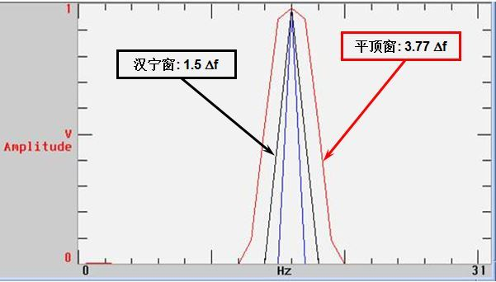

旁瓣高低及其衰减率影响能量泄漏程度（频谱拖尾效应）。旁瓣越高，说明能量泄漏越严重，衰减越慢，频谱拖尾越严重。对50.5Hz（频率分辨率为1Hz）的信号分别施加矩形窗（红色）、汉宁窗（绿色）和平顶窗（蓝色），用对数显示幅值，加窗后的结果如下图所示。从图中可以看出，矩形窗的频谱拖尾更严重。

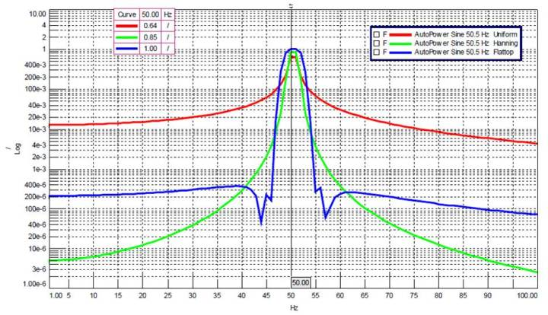

相对而言，如果旁瓣能量较小，高度趋于零，使得信号能量相对集中于主瓣，则较为接近真实的频谱。不同的窗函数对信号频谱的影响是不一样的，这主要是因为不同的窗函数，产生泄漏的大小不一样，频率分辨能力也不一样。

4. 加窗函数的原则；加窗函数时，应使窗函数频谱的主瓣宽度应尽量窄，以获得高的频率分辨能力；旁瓣衰减应尽量大，以减少频谱拖尾，但通常都不能同时满足这两个要求。

因而，窗函数的选择一般原则如下：

* 如果截断的信号仍为周期信号，则不存在泄漏，无须加窗，相当于加矩形窗。
* 如果信号是随机信号或者未知信号，或者有多个频率分量，测试关注的是频率点而非能量大小，建议选择汉宁窗，像LMS Test.Lab中默认加的就是汉宁窗。
* 对于校准目的，则要求幅值精确，平顶窗是个不错的选择。
* 如果同时要求幅值精度和频率精度，可选择凯塞窗。
* 如果检测两个频率相近、幅值不同的信号，建议用布莱克曼窗。
* 锤击法试验力信号加力窗，响应可加指数窗。

5. 模态测试所用窗函数；

对于锤击法测试，应尽量实现无泄漏的测量，即响应不需要加指数窗，因为加窗之后，相对而言，阻尼会是过估计，使得估计出来的阻尼大于实际的阻尼。因此，可以通过增加采样时间，使响应有足够的时间衰减，以避免加窗。

对于激振器测试最常用是矩形窗和汉宁窗。需要明白的是所有窗函数都会使数据失真。需要记住的是窗函数总是会使测到的峰值发生失真，并且总会给出这样的假象：测量得到的FRF中的结构阻尼大于结构实际存在的阻尼，而这两个非常重要的属性刚好是我们需要从FRF中估计的属性。矩形窗会使得幅值失真36%，汉宁窗失真16%。FRF的幅值失真从而使得阻尼估计不准确

6. 窗函数带来的影响。

如果对信号施加了窗函数，则频谱还需要进行修正。修正分幅值修正和能量修正，如果是单条谱线则为幅值修正；如果是宽带则为能量修正。

#### A2窗函数在图像处理中的应用

<https://www.smwenku.com/a/5b86bd472b71775d1cd5c9d8/zh-cn/>

例1 频谱混乱的三角函数图像

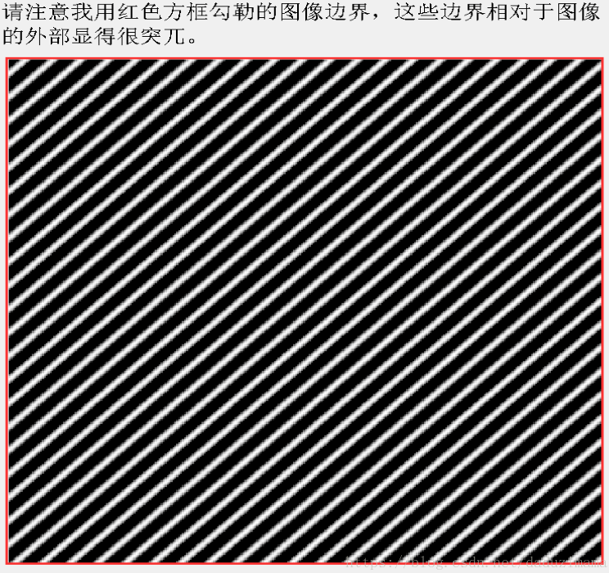 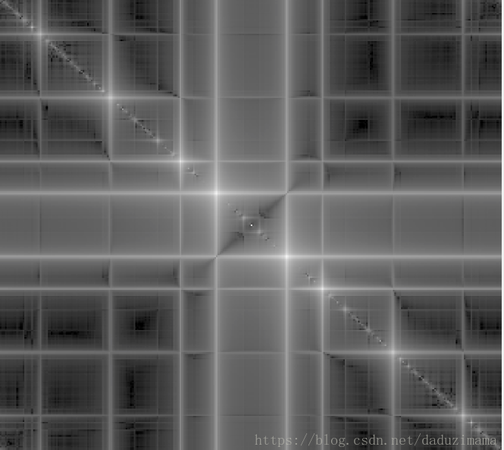

频谱混乱的原因

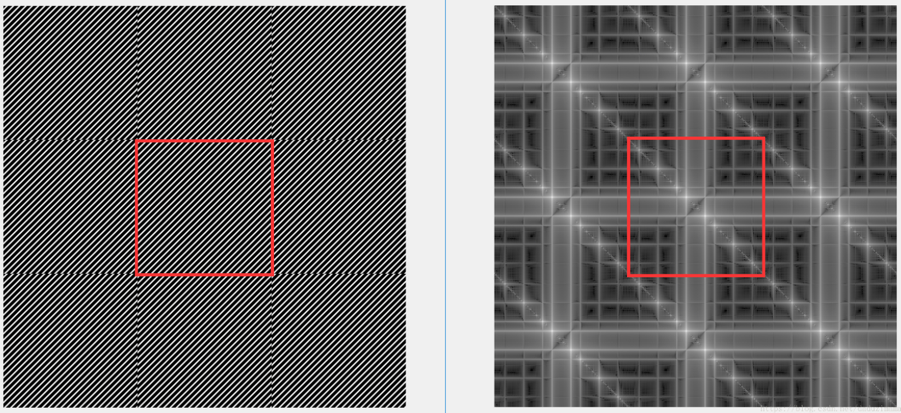

左图中（空间域）余弦信号图和他相邻的图像在红色边缘处的各种不连续（discontinuity）。这种不连续直接导致了右图中（频率域）及其混乱，复杂的频谱。所以，在处理任何图像时，千万不要忽视了图像的边缘。比如说，FFT之前的0填充，这也是一种会经常用到的避免频谱泄漏的有效方式。

对图像加窗

加窗后的频谱图远比加窗前的更集中，更清晰。

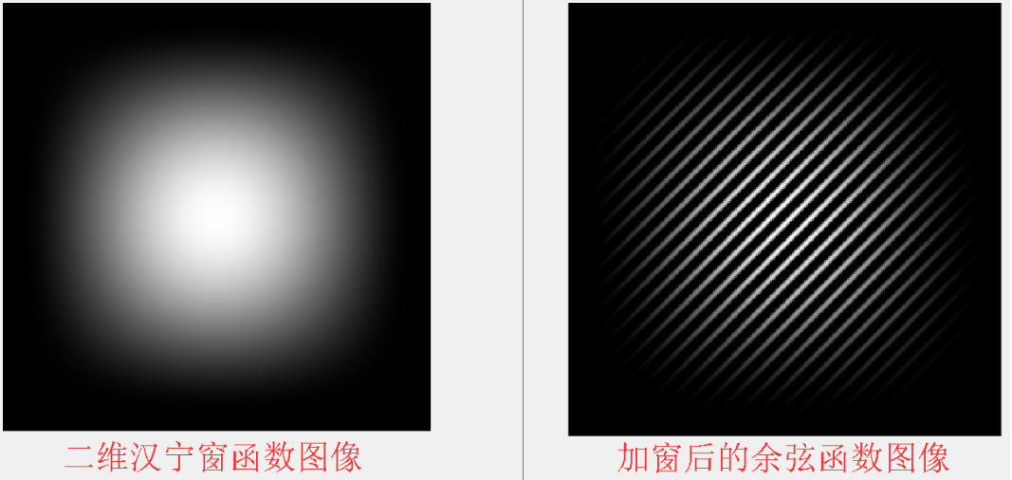

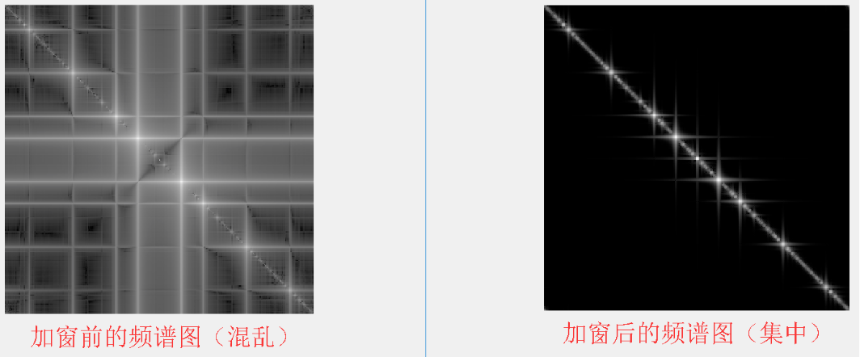

例2 著名的Cameraman.tiff

例1，空间域的不连续是非常明显，显而易见的。例2，边界上的跳变远没有例1那么明显，但也会引起频谱的泄露，污染了（smear）真实的频谱信息，而这种情况最为常见，最容易被忽视。

下图为cameraman的原图和频谱图，注意频谱图中用箭头标出的一条白色的中轴线，也是频谱的泄漏造成的。

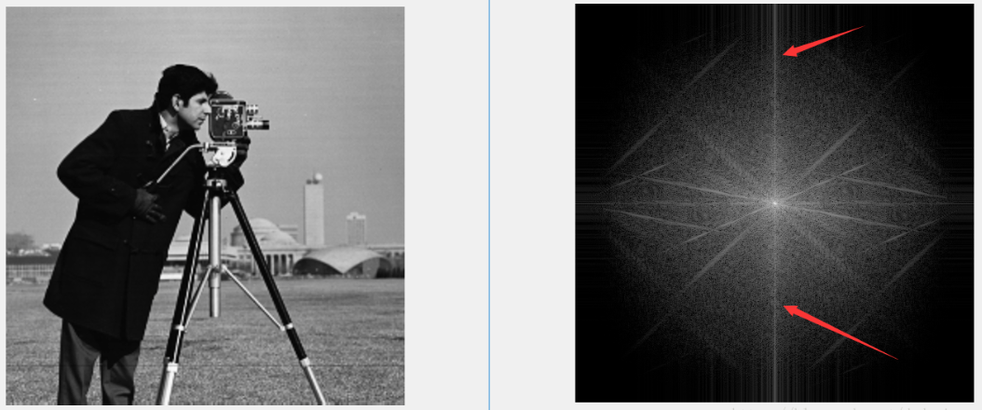

产生这根白线的原因主要是，原始图像在DFT周期复制的时候，头顶的蓝天部分较亮，而脚下草坪部分较暗。由于图像横向边缘的灰度值突变（见下图），在频谱图中的Y方向产生了频谱的泄露。当然了，图像的纵向边缘也能看到一些灰度的不平滑过渡，势必也会引起图像频谱在X方向的改变，但在此例中并不明显。

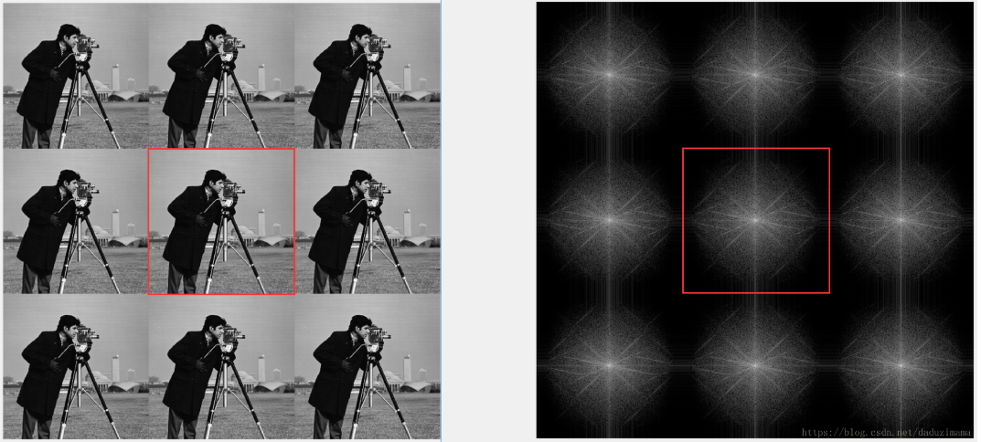

下面看看加窗后的图像和加窗后频谱的改变

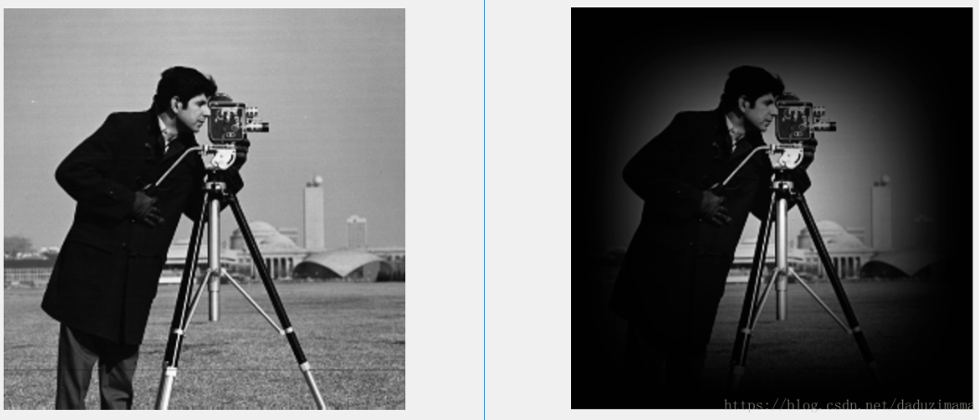

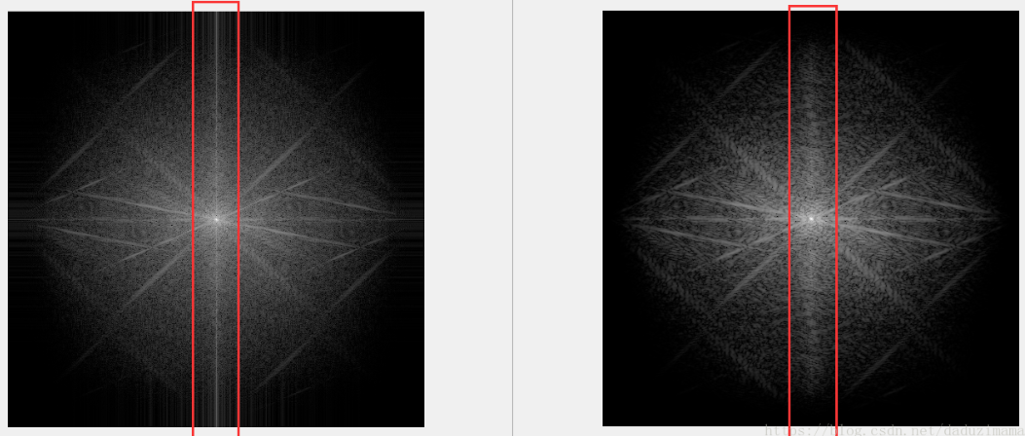

例3 上三角矩阵和下三角矩阵

理论上讲上三角矩阵和下三角矩阵的频谱都应该都只有一条斜线，不管是左斜还有右斜，但是往往大家看到的上/下三角矩阵的频谱图当中还有一个十字架。这都是因为没有加窗出现了DFT周期性的边界不连续。

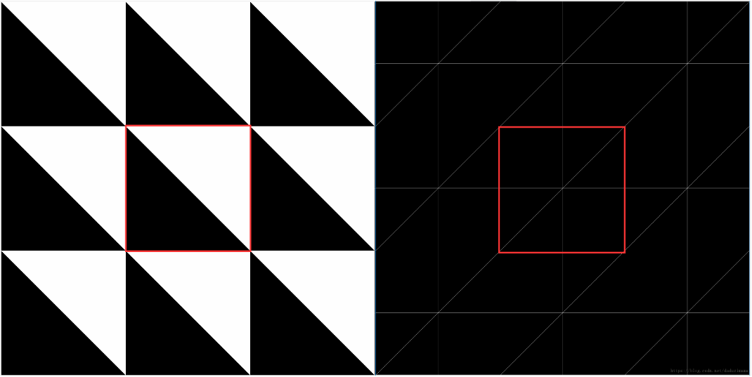

注意图中的十字架，这是本不该出现在频谱图中的成分。

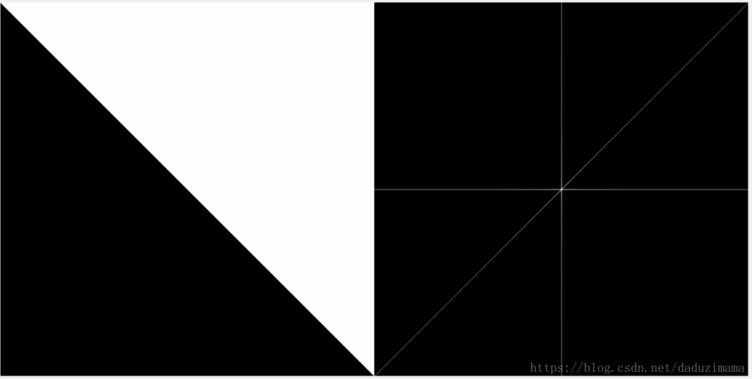

下图是加窗后的真实频谱，见下图

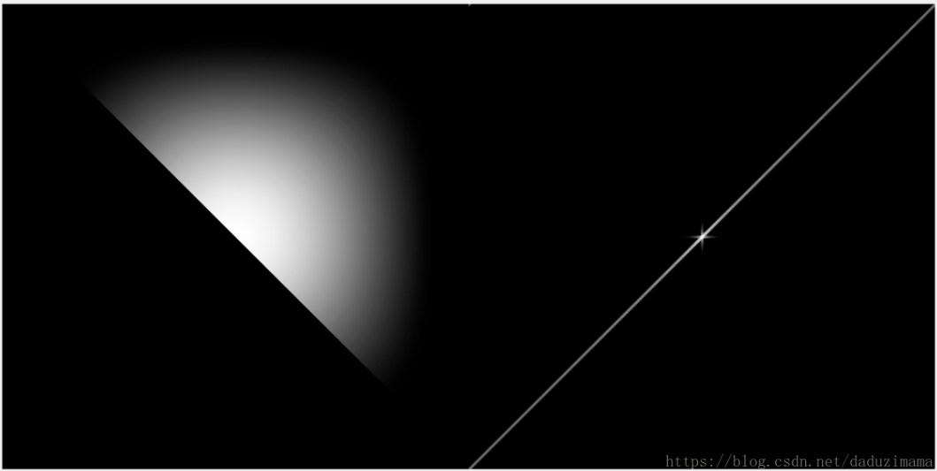

#### A3栅栏现象

https://baike.baidu.com/item/%E6%A0%85%E6%A0%8F%E7%8E%B0%E8%B1%A1

也称栅栏效应，对一函数实行采样，即是抽取采样点上的对应的函数值。其效果如同透过栅栏的缝隙观看外景一样，只有落在缝隙前的少数景象被看到，其余景象均被栅栏挡住而视为零，这种现象称为栅栏效应。